***One People, One Purpose, One Practice***

First Pilgrim Calvary Missionary Baptist Church

11435 Hwy 73

Geismar, LA 70734

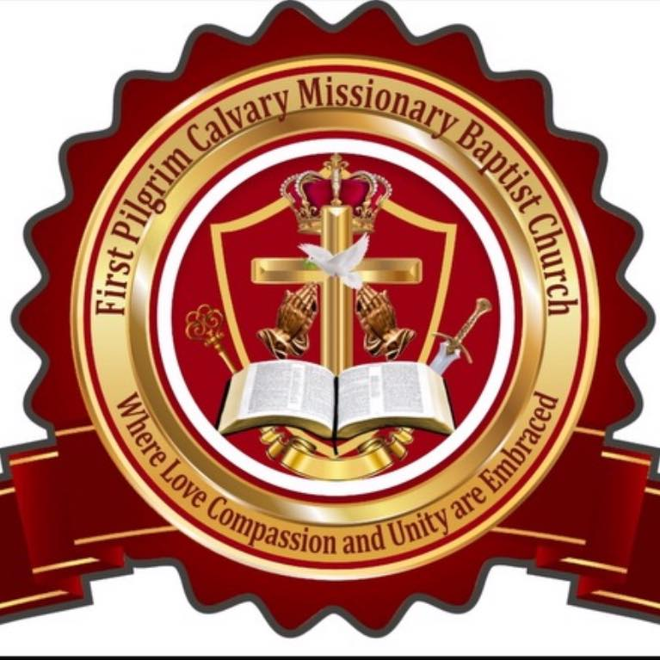



Phone Number: (225) 673-1673

Email address: firstpcmbc@gmail.com

Website: https://www.firstpcmbc.com/

**Marlon Henderson, Sr. *Senior Pastor***

Bible Study Wednesday, January 22, 2025

**“Formed by the Spirit: Growing in Christlikeness”**

(Romans 12:1-2)

*"Formed by the Spirit: Growing in Christlikeness"* is a transformative Bible study series designed to guide believers in their spiritual journey. Rooted in Romans 12:1-2, this series explores the process of spiritual formation—becoming more like Christ through the renewing work of the Holy Spirit. Each lesson builds on the last, offering practical steps, biblical insights, and spiritual disciplines to help you deepen your relationship with God and reflect His glory in your daily life. Join us as we surrender to God's shaping hand and grow together in faith.

**What is Spiritual Formation?**

Spiritual formation is the ongoing process of becoming more like Christ. It’s a journey powered by the Holy Spirit, rooted in Scripture, and requiring our daily cooperation with God. This lesson will explore what spiritual formation is, why it matters, and how we can participate.

1. **Understanding Spiritual Formation**

* **Definition:** Spiritual formation is the process by which believers are transformed into the likeness of Christ through the work of the Holy Spirit (Romans 8:29).
* **Purpose:** To glorify God by reflecting His character in our lives (Matthew 5:16).
* **God’s Role:** The Holy Spirit is the primary agent, guiding and empowering us in transformation (2 Corinthians 3:18).
* **Our Role:** To submit, seek, and obey God’s leading (Philippians 2:12-13).

1. **Key Aspects of Spiritual Formation**

* **Beholding Christ:** Fix your eyes on Jesus through prayer, worship, and Scripture meditation.
* **Transformation by the Spirit:** Allow the Spirit to shape your thoughts, attitudes, and actions.
* **Glory to Glory:** Growth is progressive, not instant. Be patient as God works.

1. **Practical Application**

This week, reflect on the following steps to deepen your understanding and experience of spiritual formation:

* **Daily Devotion:** Spend at least 15 minutes in Scripture and prayer, asking the Holy Spirit to guide your growth.
* **Memorize Scripture:** Start with 2 Corinthians 3:18. Reflect on its meaning each day.
* **Examine Your Life:** Identify one habit, thought pattern, or attitude that doesn’t reflect Christ. Pray for the Spirit’s help to change it.